3030
Welcome To
Trinity Lutheran Church
Lutheran Church—Missouri Synod
A Stephen Ministry Congregation

1354 South Otsego Avenue
Gaylord, Michigan 49735
Church Phone: (989) 732-4816

Church Email: secretary@trinitygaylord.com
www.trinitygaylord.com

Office Hours: Monday through Friday 9am – 1pm

OUR PURPOSE
…is to LOVE GOD, LOVE OTHERS, AND SERVE THE WORLD by worshiping the Lord Jesus, bringing our members into Christ-like maturity, and equipping them through Word and Sacrament for their mission and ministry. We go heart to heart into the world with Jesus, sharing His love, caring for one another, praying, and bringing the lost into a relationship with Christ, by the working of the Holy Spirit.

December 11, 2022
Third Sunday in Advent
Preacher: Rev. Ken Bernthal

ABOUT OUR WORSHIP
We welcome all who gather here today! We are blessed to celebrate together the mercy, grace, and love we have from God through the death and resurrection of our Lord Jesus Christ.

Children: Families with children are very welcome here. Having children in church is important so they can begin to learn about their faith in Jesus, and it’s good for the whole congregation to see. Please feel comfortable keeping “squirmy” kids in the service. This is where they belong, too!

Pew Cards: Guests and Members, please fill out the Guest/Member card located on the back of the pew in front of you and pass it to the end of the aisle. If you forget you can put it in the offering plate on your way out.

If standing is difficult: Please feel free to remain seated during any portion of the service. Please let an Elder or Usher know if you need communion in your pew seat.

About our celebration of Holy Communion: We celebrate the Lord’s Supper in the confession and glad confidence that, as he says, our Lord gives into our mouths not only bread and wine but his very body and blood to eat and to drink for the forgiveness of sins and to strengthen our union with him and with one another. Our Lord invites to his table those who trust his words, repent of all sin, and set aside any refusal to forgive and love as he forgives and loves us, that they may show forth his death until he comes.
Because those who eat and drink our Lord’s body and blood contrary to that which is stated above do so to their great harm, and also because Holy Communion is a confession of the faith which is confessed at this altar. Anyone who is not yet instructed, in doubt, or who hold a confession differing from that of the Lutheran Church—Missouri Synod, and yet desire to receive the sacrament, are asked first to speak with Pastor. Those not communing are still invited to come forward for a blessing from Pastor, and you may indicate this by crossing your arms over your chest.
TTTTTT
GREETING
P Peace be with you.
C And also with you.

T ORDER OF SERVICE T
(The liturgy is from Divine Service Setting one LSB pg.151ff)

OPENING HYMN
Christ Be My Leader LSB 681
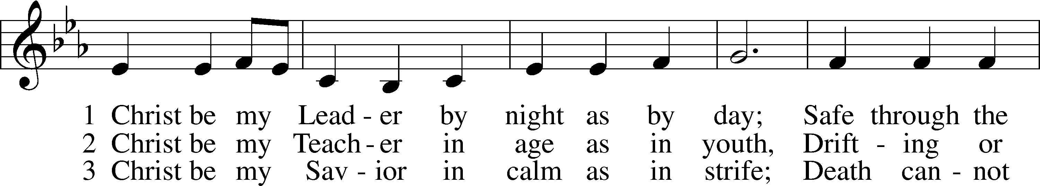
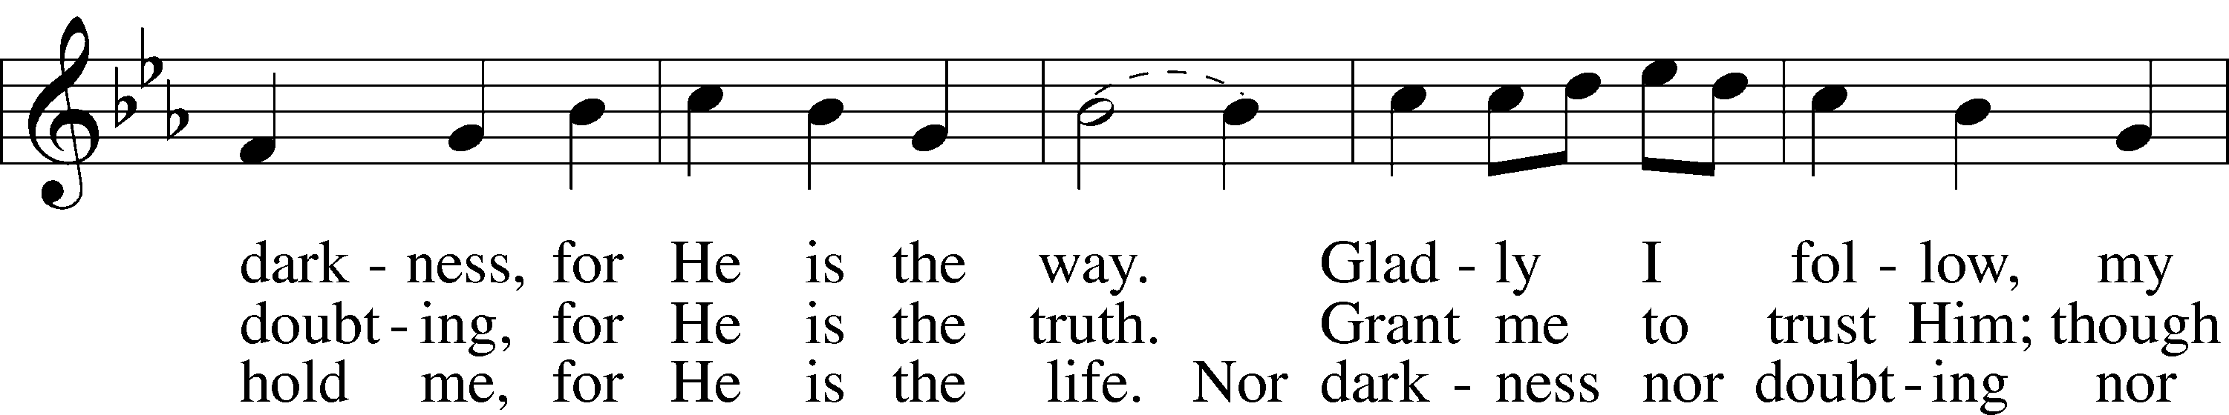
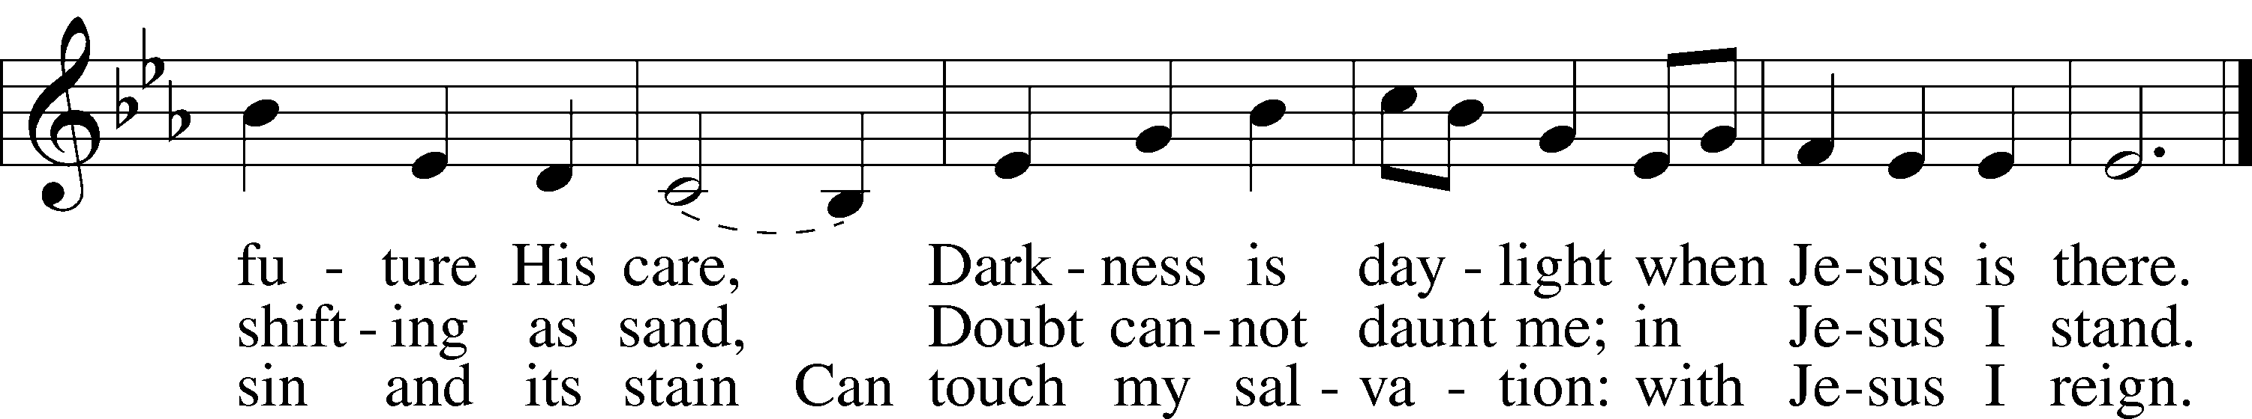

Please stand as able
CONFESSION and ABSOLUTION
The sign of the cross T may be made by all in remembrance of their Baptism.

P In the name of the Father and of the T Son and of the Holy Spirit.
C Amen.
P If we say we have no sin, we deceive ourselves, and the truth is not in us.
C But if we confess our sins, God, who is faithful and just, will forgive our sins and cleanse us from all unrighteousness.

Silence for reflection on God’s Word and for self-examination.

P Let us then confess our sins to God our Father.
C Most merciful God, we confess that we are by nature sinful and unclean. We have sinned against You in thought, word, and deed, by what we have done and by what we have left undone. We have not loved You with our whole heart; we have not loved our neighbors as ourselves. We justly deserve Your present and eternal punishment. For the sake of Your Son, Jesus Christ, have mercy on us. Forgive us, renew us, and lead us, so that we may delight in Your will and walk in Your ways to the glory of Your holy name. Amen.

P Almighty God in His mercy has given His Son to die for you and for His sake forgives you all your sins. As a called and ordained servant of Christ, and by His authority, I therefore forgive you all your sins in the name of the Father and of the T Son and of the Holy Spirit.
C Amen.

T SERVICE OF THE WORD T
INTROIT

P Rejoice in the Lord always; again I will say, Rejoice.
C I will hope continually and will praise You yet more and more.

P My mouth will tell of Your righteous acts, of Your deeds of salvation all the day, for their number is past my knowledge.
C With the mighty deeds of the Lord God I will come; I will remind them of Your righteousness, Yours alone.

P O God, from my youth You have taught me, and I still proclaim Your wondrous deeds.
C So even to old age and gray hairs, O God, do not forsake me, until I proclaim Your might to another generation, Your power to all those to come.

A Glory be to the Father and to the Son and to the Holy Spirit;
as it was in the beginning, is now, and will be forever. Amen.
P Rejoice in the Lord always; again I will say, Rejoice.

KYRIE Pg. 152

P In peace let us pray to the Lord.
C Lord, have mercy.
P For the peace from above and for our salvation let us pray to the Lord.
C Lord, have mercy.
P For the peace of the whole world, for the well-being of the Church of God, and for the unity of all let us pray to the Lord.
C Lord, have mercy.
P For this holy house and for all who offer here their worship and praise let us pray to the Lord.
C Lord, have mercy.
P Help, save, comfort, and defend us, gracious Lord.
C Amen.

HYMN OF PRAISE
This Is the Feast LSB 155
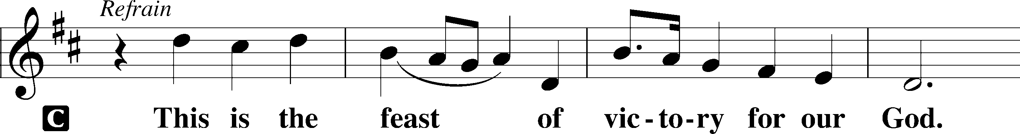
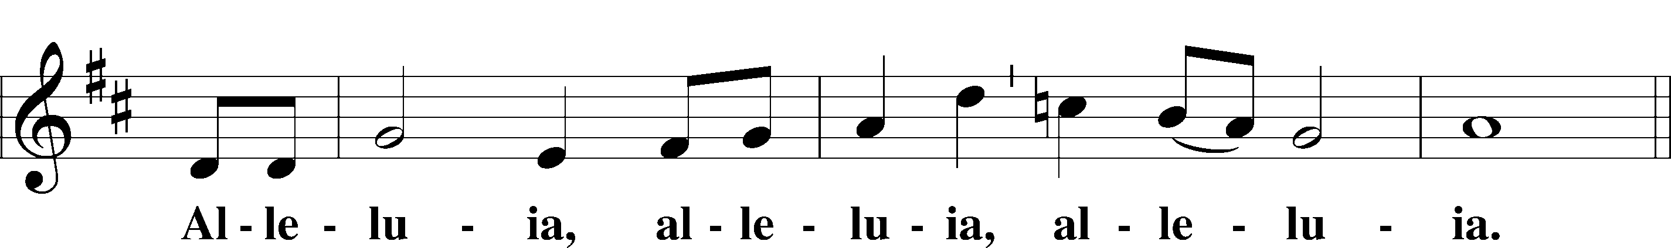
Continued on next page
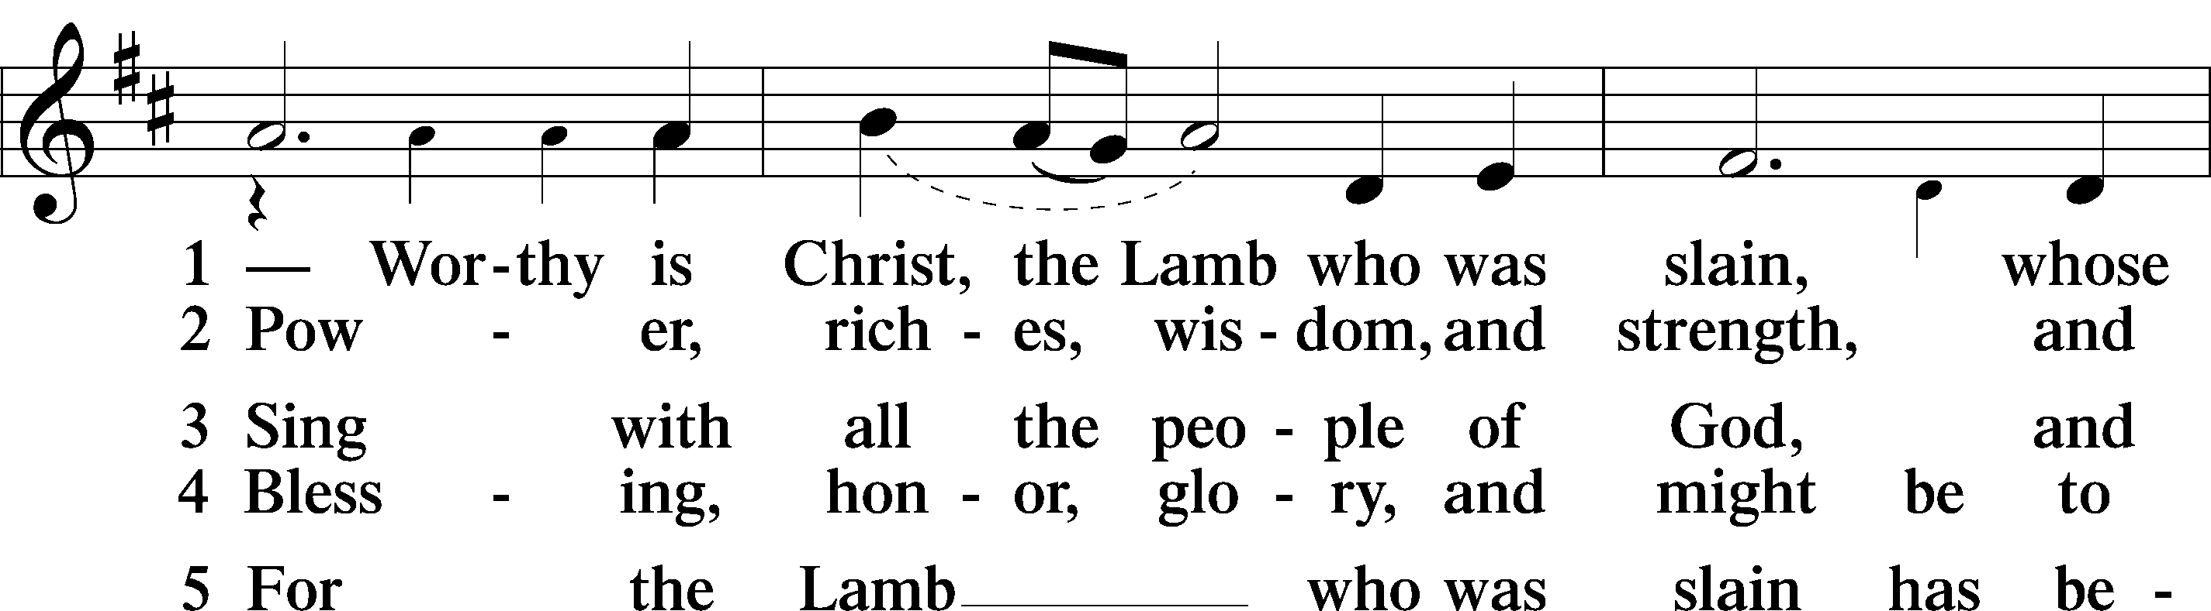
Continued on next page
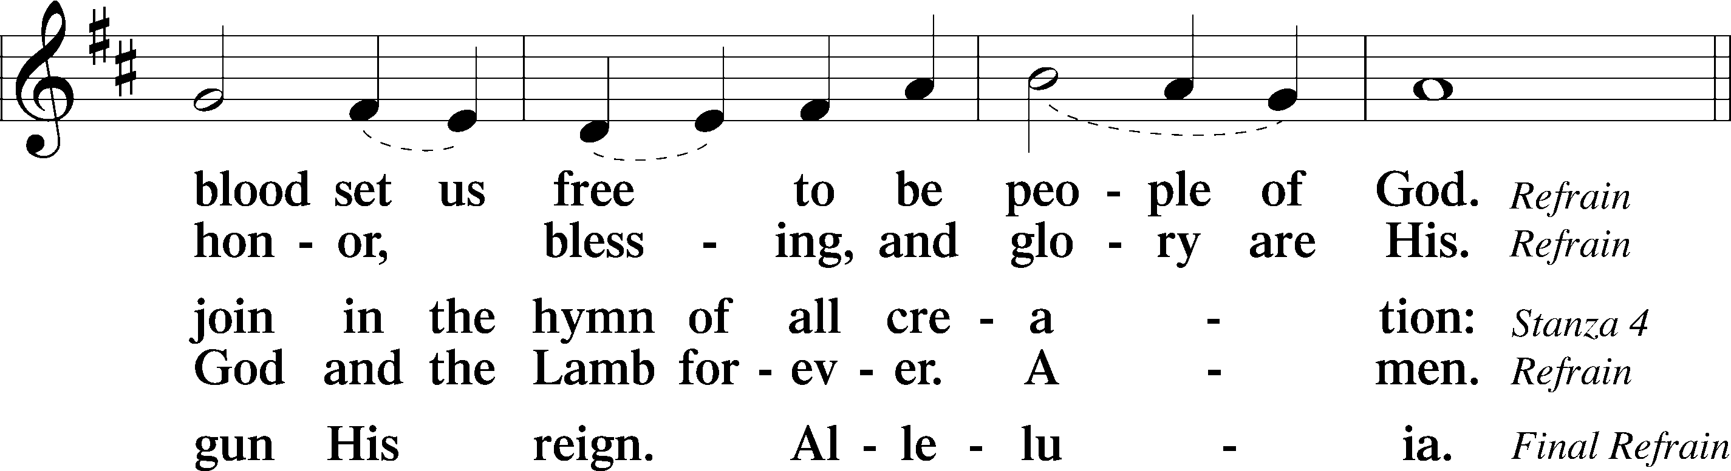
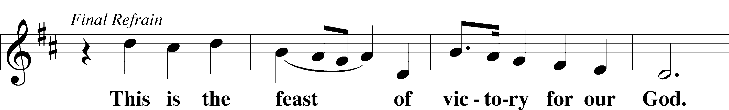
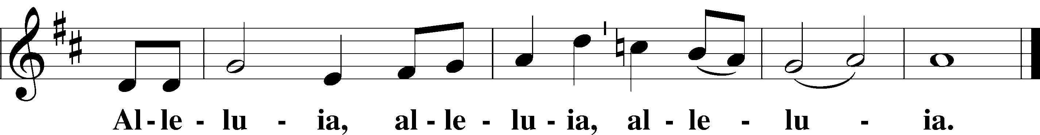

SALUTATION AND COLLECT OF THE DAY
P The Lord be with you.
C And also with you.

P Let us pray.
Lord Jesus Christ, we implore You to hear our prayers and to lighten the darkness of our hearts by Your gracious visitation; for You live and reign with the Father and the Holy Spirit, one God, now and forever.
C Amen.

Please be seated

OLD TESTAMENT READING Isaiah 35:1–10
¹The wilderness and the dry land shall be glad;
the desert shall rejoice and blossom like the crocus;
²it shall blossom abundantly
and rejoice with joy and singing.
The glory of Lebanon shall be given to it,
the majesty of Carmel and Sharon.
They shall see the glory of the Lord,
the majesty of our God.
³Strengthen the weak hands,
and make firm the feeble knees.
⁴Say to those who have an anxious heart,
“Be strong; fear not!
Behold, your God
will come with vengeance,
with the recompense of God.
He will come and save you.”
⁵Then the eyes of the blind shall be opened,
and the ears of the deaf unstopped;
⁶then shall the lame man leap like a deer,
and the tongue of the mute sing for joy.
For waters break forth in the wilderness,
and streams in the desert;
⁷the burning sand shall become a pool,
and the thirsty ground springs of water;
in the haunt of jackals, where they lie down,
the grass shall become reeds and rushes.
⁸And a highway shall be there,
and it shall be called the Way of Holiness;
the unclean shall not pass over it.
It shall belong to those who walk on the way;
even if they are fools, they shall not go astray.
⁹No lion shall be there,
nor shall any ravenous beast come up on it;
they shall not be found there,
but the redeemed shall walk there.
¹⁰And the ransomed of the Lord shall return
and come to Zion with singing;
everlasting joy shall be upon their heads;
they shall obtain gladness and joy,
and sorrow and sighing shall flee away.
P This is the Word of the Lord.
C Thanks be to God.

CHOIR “How Can I Keep From Singing?”
EPISTLE James 5:7–11
⁷Be patient, therefore, brothers, until the coming of the Lord. See how the farmer waits for the precious fruit of the earth, being patient about it, until it receives the early and the late rains. ⁸You also, be patient. Establish your hearts, for the coming of the Lord is at hand. ⁹Do not grumble against one another, brothers, so that you may not be judged; behold, the Judge is standing at the door. ¹⁰As an example of suffering and patience, brothers, take the prophets who spoke in the name of the Lord. ¹¹Behold, we consider those blessed who remained steadfast. You have heard of the steadfastness of Job, and you have seen the purpose of the Lord, how the Lord is compassionate and merciful.

P This is the Word of the Lord.
C Thanks be to God.

Please stand as able

ALLELUIA AND VERSE LSB 156
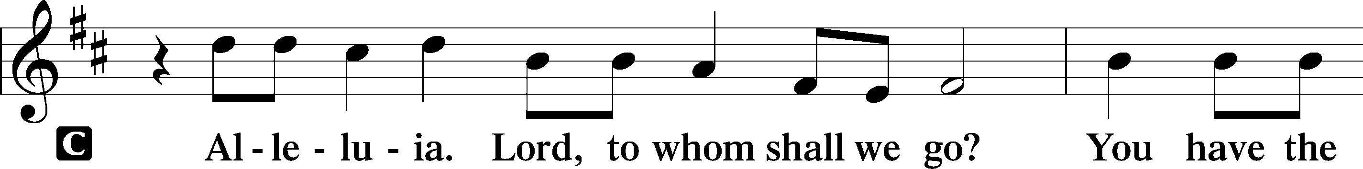
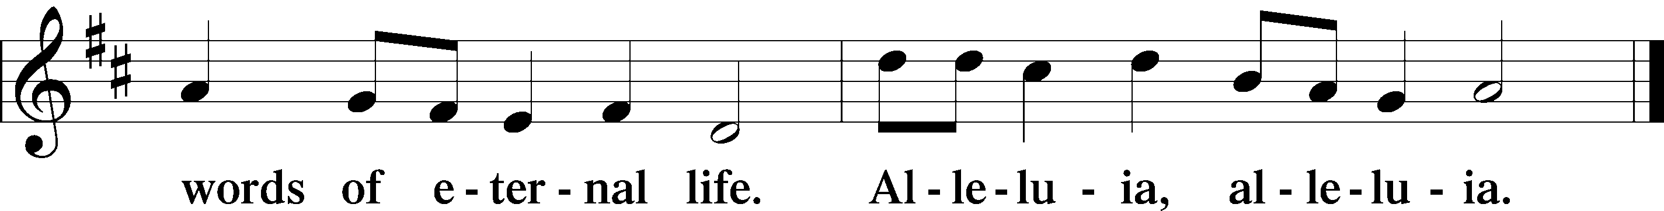

HOLY GOSPEL Matthew 11:2–15
P The Holy Gospel according to St. Matthew, the eleventh chapter.
C Glory to You, O Lord.

²When John heard in prison about the deeds of the Christ, he sent word by his disciples ³and said to him, “Are you the one who is to come, or shall we look for another?” ⁴And Jesus answered them, “Go and tell John what you hear and see: ⁵the blind receive their sight and the lame walk, lepers are cleansed and the deaf hear, and the dead are raised up, and the poor have good news preached to them. ⁶And blessed is the one who is not offended by me.”
⁷As they went away, Jesus began to speak to the crowds concerning John: “What did you go out into the wilderness to see? A reed shaken by the wind? ⁸What then did you go out to see? A man dressed in soft clothing? Behold, those who wear soft clothing are in kings’ houses. ⁹What then did you go out to see? A prophet? Yes, I tell you, and more than a prophet. ¹⁰This is he of whom it is written,
“‘Behold, I send my messenger before your face,
who will prepare your way before you.’
¹¹Truly, I say to you, among those born of women there has arisen no one greater than John the Baptist. Yet the one who is least in the kingdom of heaven is greater than he. ¹²From the days of John the Baptist until now the kingdom of heaven has suffered violence, and the violent take it by force. ¹³For all the Prophets and the Law prophesied until John, ¹⁴and if you are willing to accept it, he is Elijah who is to come. ¹⁵He who has ears to hear, let him hear.”

P This is the Gospel of the Lord.
C Praise to You, O Christ.

Please be seated

NICENE CREED
C I believe in one God,
the Father Almighty,
maker of heaven and earth
and of all things visible and invisible.
And in one Lord Jesus Christ,
the only-begotten Son of God,
begotten of His Father before all worlds,
God of God, Light of Light,
very God of very God,
begotten, not made,
being of one substance with the Father,
by whom all things were made;
who for us men and for our salvation came down from heaven
and was incarnate by the Holy Spirit of the virgin Mary
and was made man;
and was crucified also for us under Pontius Pilate.
He suffered and was buried.
And the third day He rose again according to the Scriptures
and ascended into heaven
and sits at the right hand of the Father.
And He will come again with glory to judge both the living and the dead,
whose kingdom will have no end.
And I believe in the Holy Spirit,
the Lord and giver of life,
who proceeds from the Father and the Son,
who with the Father and the Son together is worshiped and glorified,
who spoke by the prophets.
And I believe in one holy Christian and apostolic Church,
I acknowledge one Baptism for the remission of sins,
and I look for the resurrection of the dead
and the life T of the world to come. Amen.

SERMON HYMN
Jerusalem the Golden LSB 672 stand on st. 4
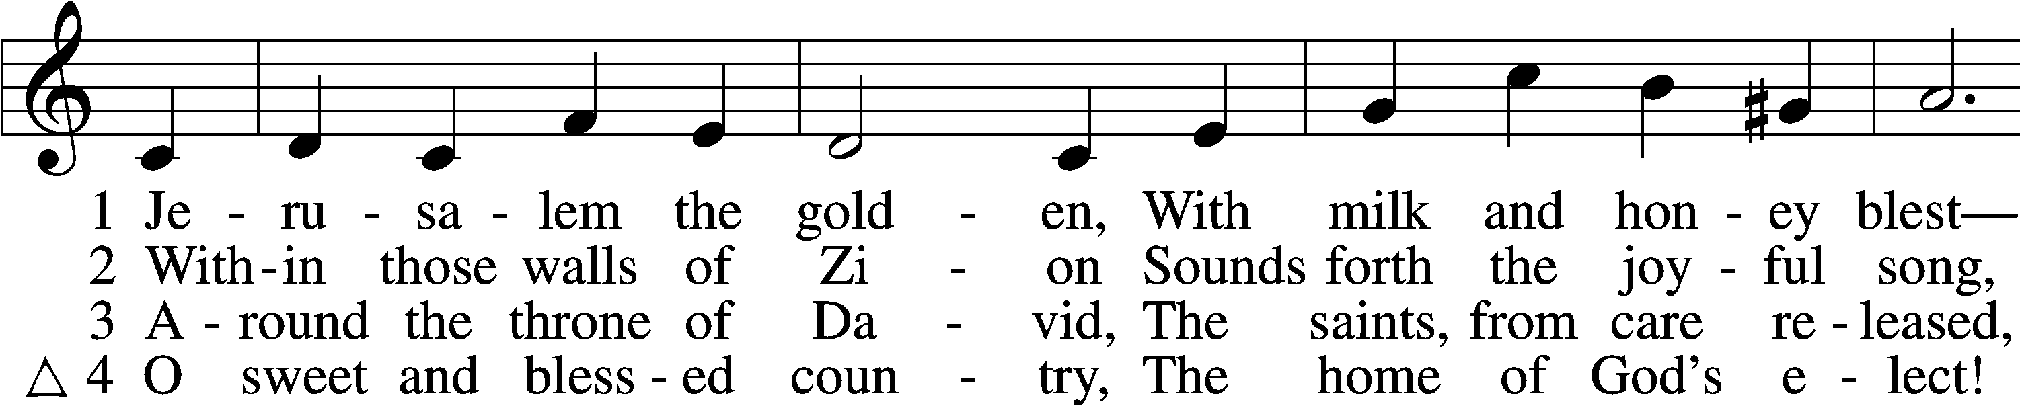
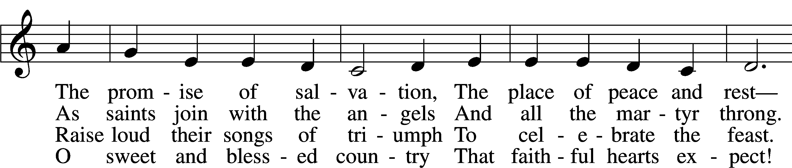
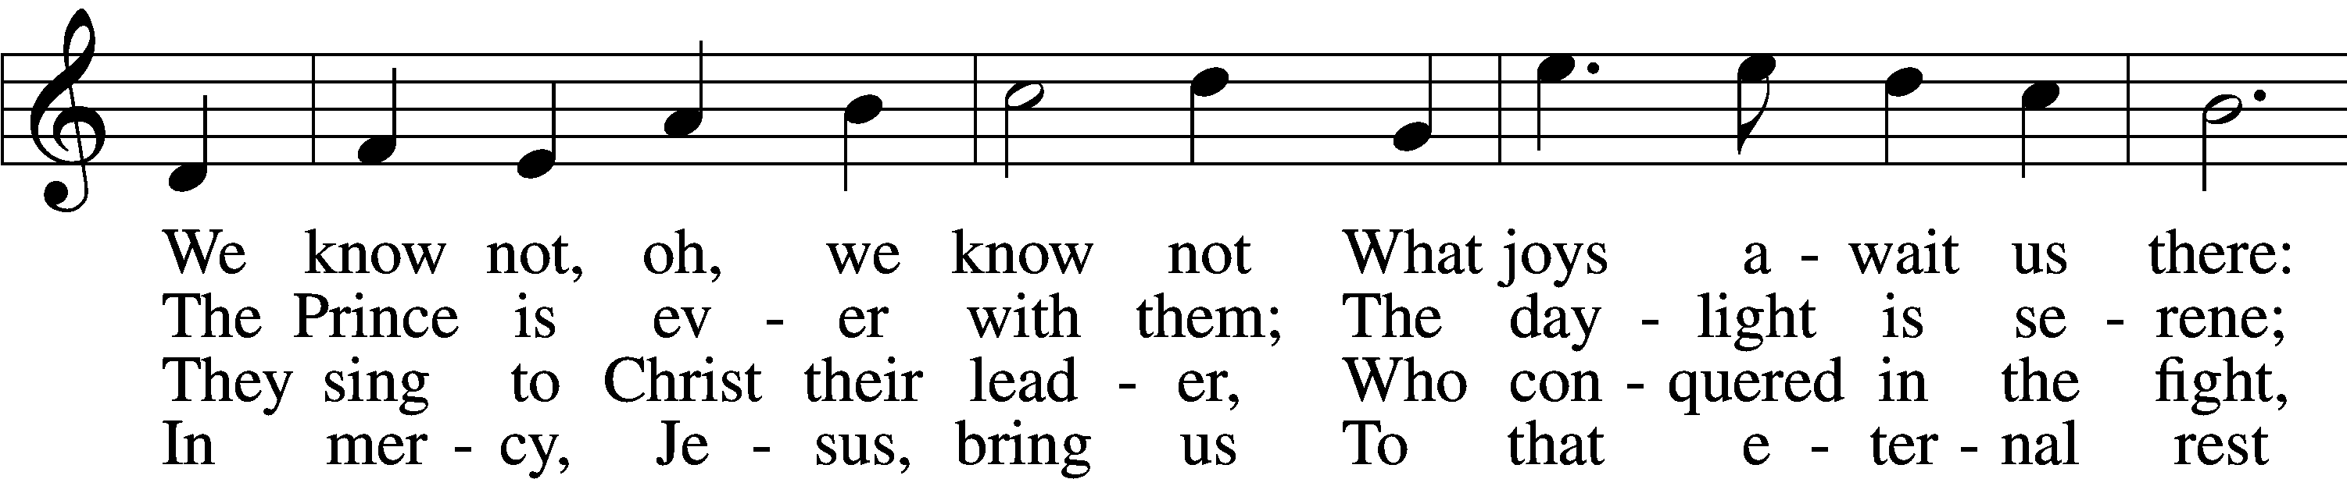
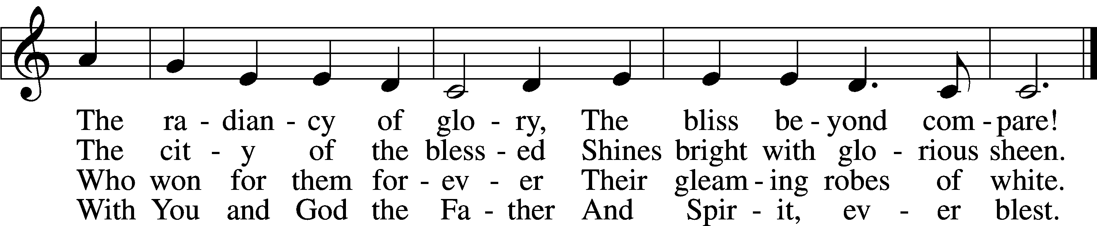

SERMON

Please stand as able

PRAYER of the CHURCH
After each Segment:
P Lord, in Your Mercy,
C Hear our Prayer.
After Final Segment:
P Hear us as we pray in His name and as He has taught us:
LORD’S PRAYER
C Our Father who art in heaven,
hallowed be Thy name,
Thy kingdom come,
Thy will be done on earth
as it is in heaven;
give us this day our daily bread;
and forgive us our trespasses
as we forgive those
who trespass against us;
and lead us not into temptation,
but deliver us from evil.
For Thine is the kingdom
and the power and the glory
forever and ever. Amen.

T SERVICE of the SACRAMENT T

PREFACE LSB 160
P The Lord be with you.
C And also with you.
P Lift up your hearts.
C We lift them to the Lord.
P Let us give thanks to the Lord our God.
C It is right to give Him thanks and praise.
P It is truly good, right, and salutary that we should at all times and in all places give thanks to You, O Lord, holy Father, almighty and everlasting God, for the countless blessings You so freely bestow on us and all creation. Above all, we give thanks for Your boundless love shown to us when You sent Your only-begotten Son, Jesus Christ, into our flesh and laid on Him our sin, giving Him into death that we might not die eternally. Because He is now risen from the dead and lives and reigns to all eternity, all who believe in Him will overcome sin and death and will rise again to new life. Therefore with angels and archangels and with all the company of heaven we laud and magnify Your glorious name, evermore praising You and singing:

SANCTUS LSB 161
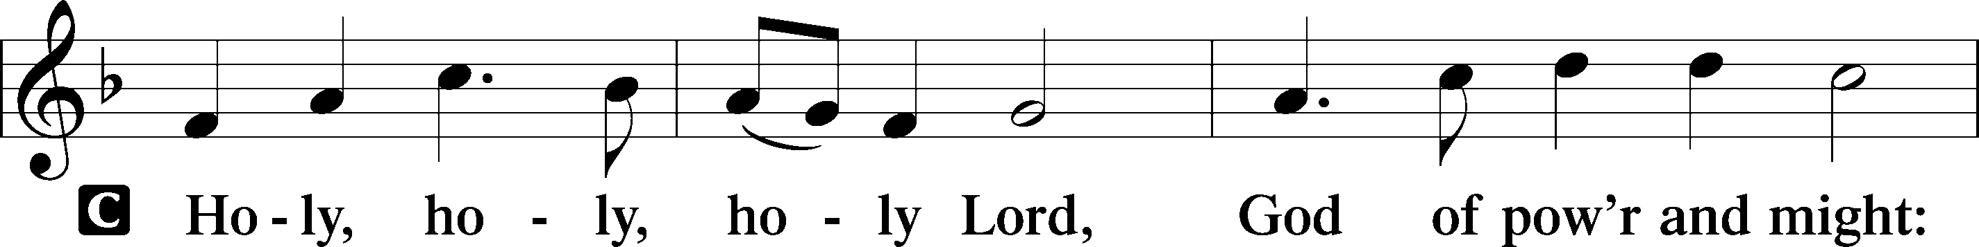
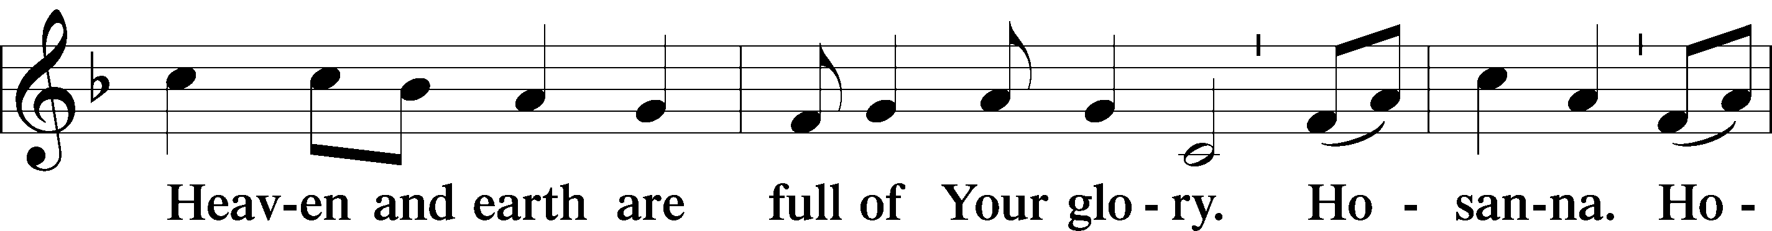
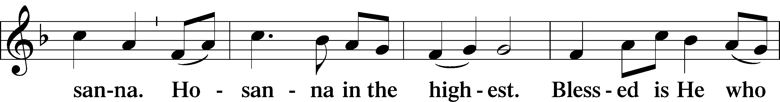
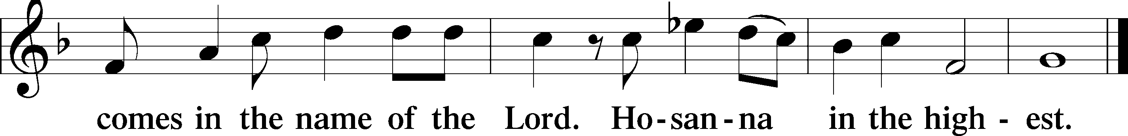
THE WORDS OF OUR LORD
P Our Lord Jesus Christ, on the night when He was betrayed, took bread, and when He had given thanks, He broke it and gave it to the disciples and said: “Take, eat; this is My T body, which is given for you. This do in remembrance of Me.”
In the same way also, He took the cup after supper, and when He had given thanks, He gave it to them, saying: “Drink of it, all of you; this cup is the New Testament in My T blood, which is shed for you for the forgiveness of sins. This do, as often as you drink it, in remembrance of Me.”

PAX DOMINI
P The peace of the Lord be with you always.
C Amen.
AGNUS DEI LSB 163
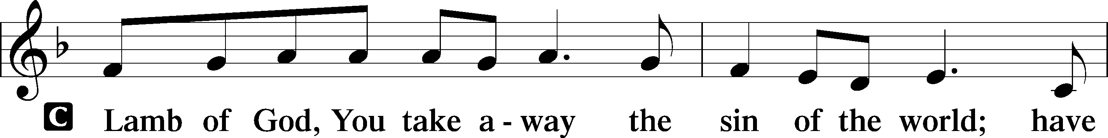
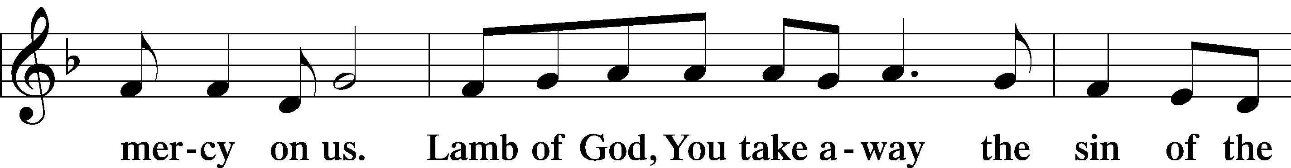
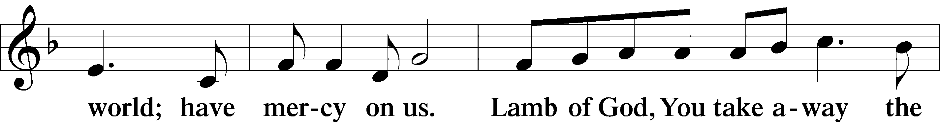
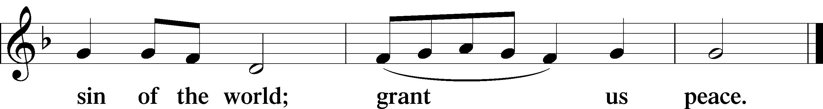
Please be seated
DISTRIBUTION
The pastor and those who assist him receive the body and blood of Christ first, then Communion will be served at the rail. Ushers will help direct you forward via the center aisle; please return to your seats via the side aisles. Gluten-free bread is available for those who need it, as is non-alcoholic grape juice. Simply request either when you come forward to receive Communion.
DISTRIBUTION HYMN
Let Us Ever Walk with Jesus LSB 685
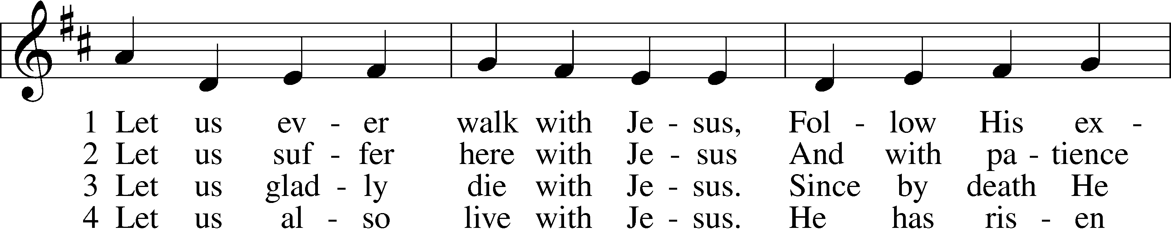
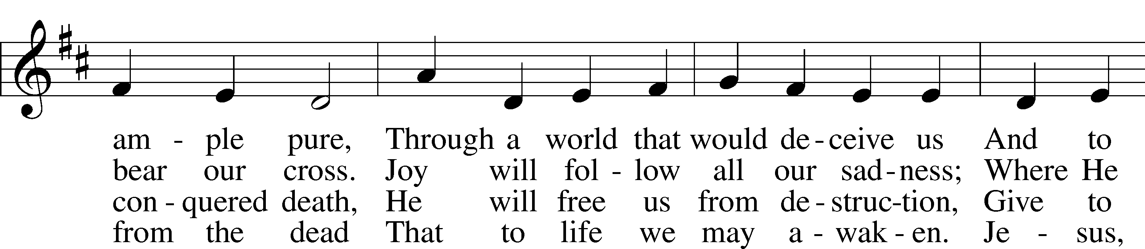
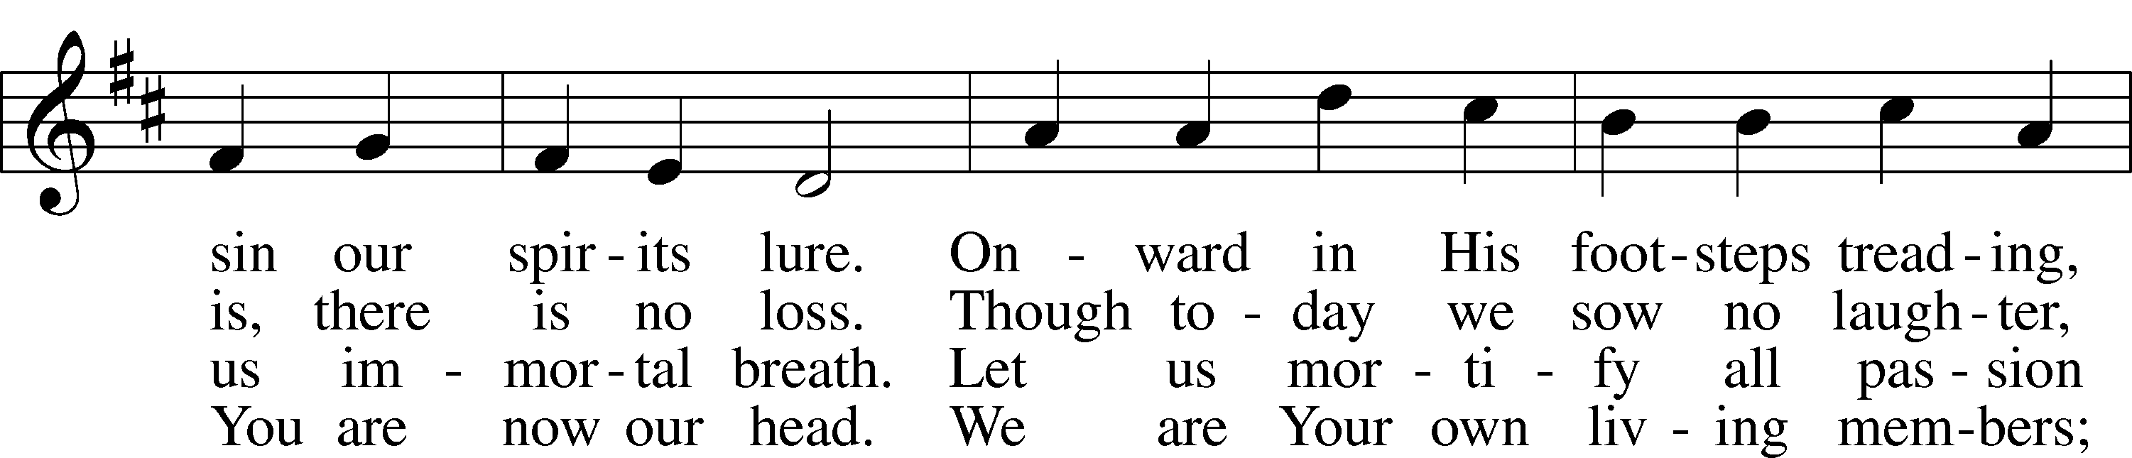
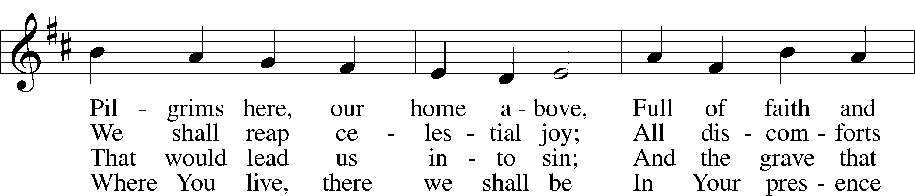

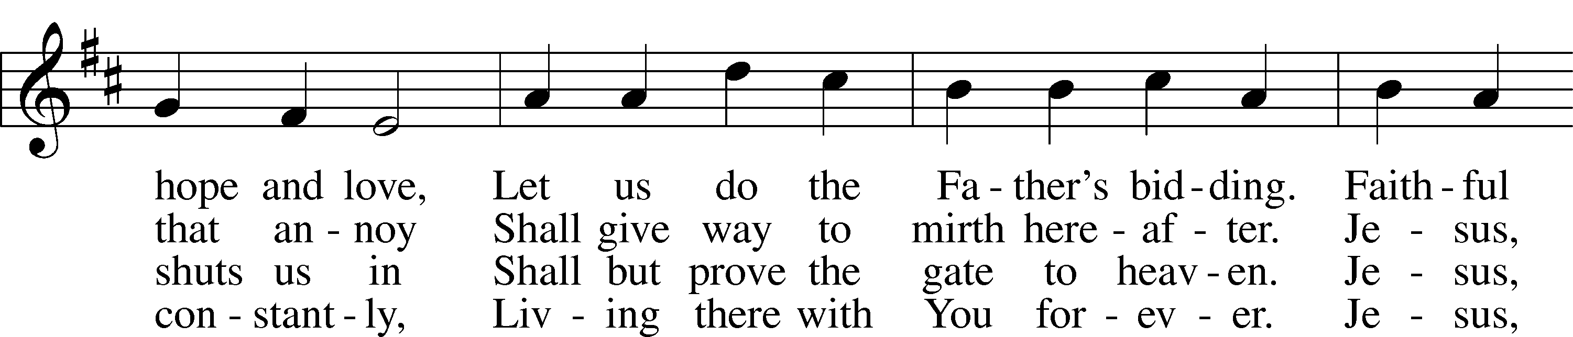
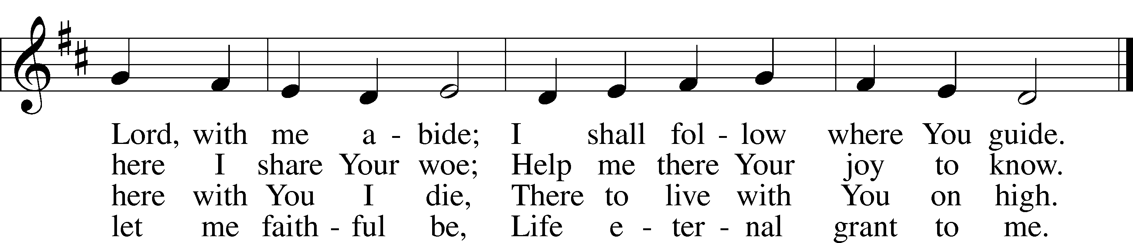

DISTRIBUTION HYMN
Lord Take My Hand and Lead Me LSB 722
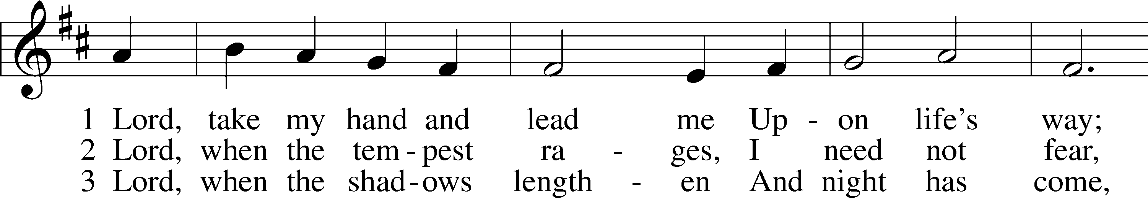
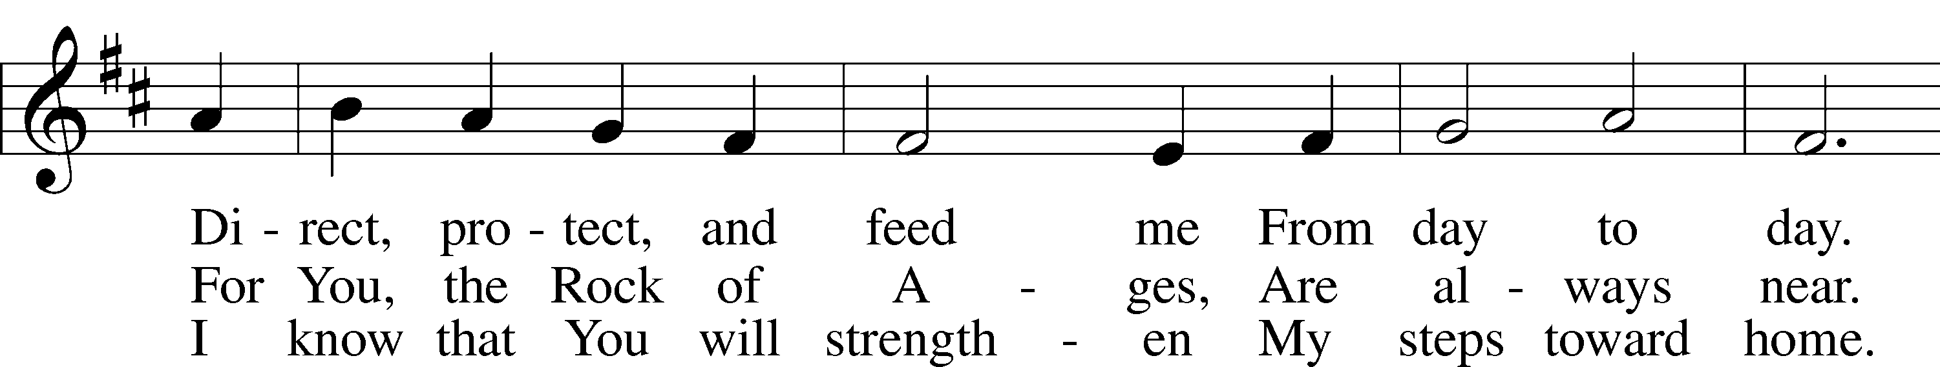
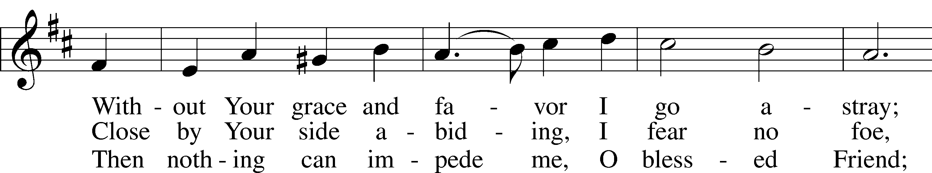
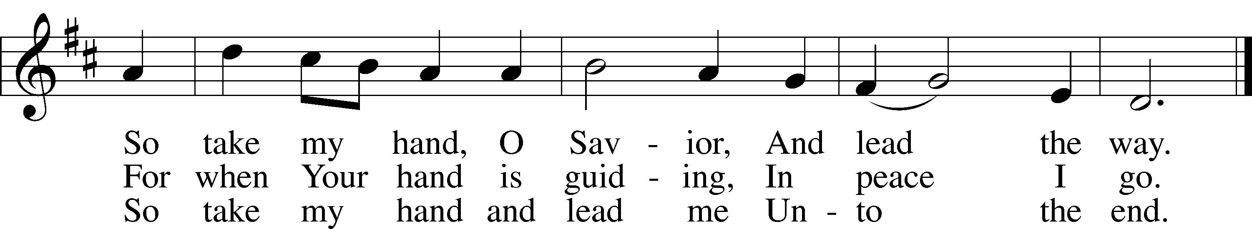
Please stand as able

POST COMMUNION CANTICLE
Thank the Lord LSB 164
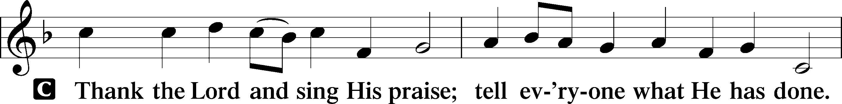
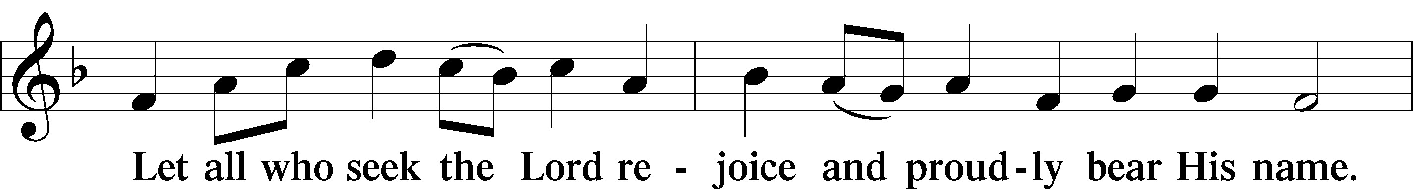
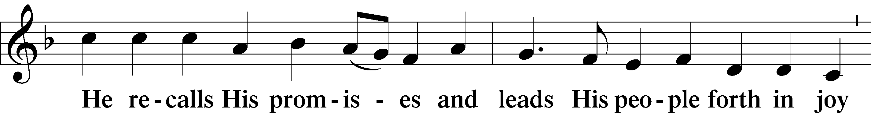
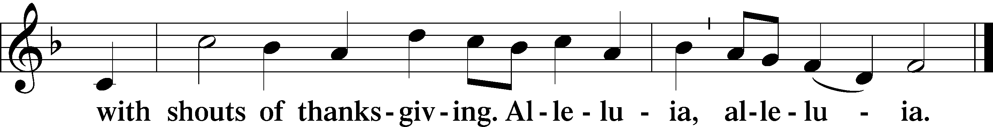

POST COMMUNION COLLECT
P Let us pray.
O God the Father, the fountain and source of all goodness, who in loving-kindness sent Your only-begotten Son into the flesh, we thank You that for His sake You have given us pardon and peace in this Sacrament, and we ask You not to forsake Your children but always to rule our hearts and minds by Your Holy Spirit that we may be enabled constantly to serve You; through Jesus Christ, Your Son, our Lord, who lives and reigns with You and the Holy Spirit, one God, now and forever.
C Amen.

BENEDICTION
P The Lord bless you and keep you.
The Lord make His face shine on you and be gracious to you.
The Lord look upon you with favor and T give you peace.
C Amen.
Please be seated
CLOSING HYMN
I’m But a Stranger Here LSB 748
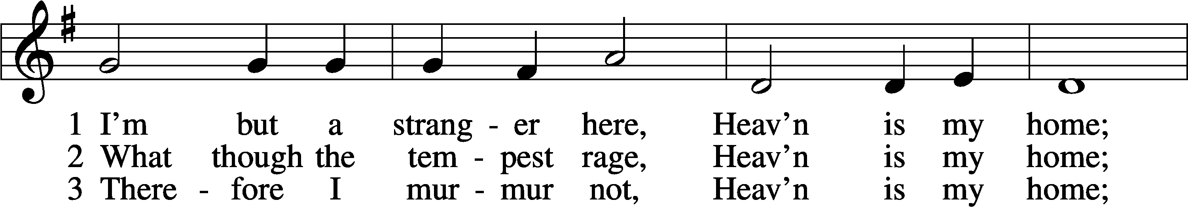
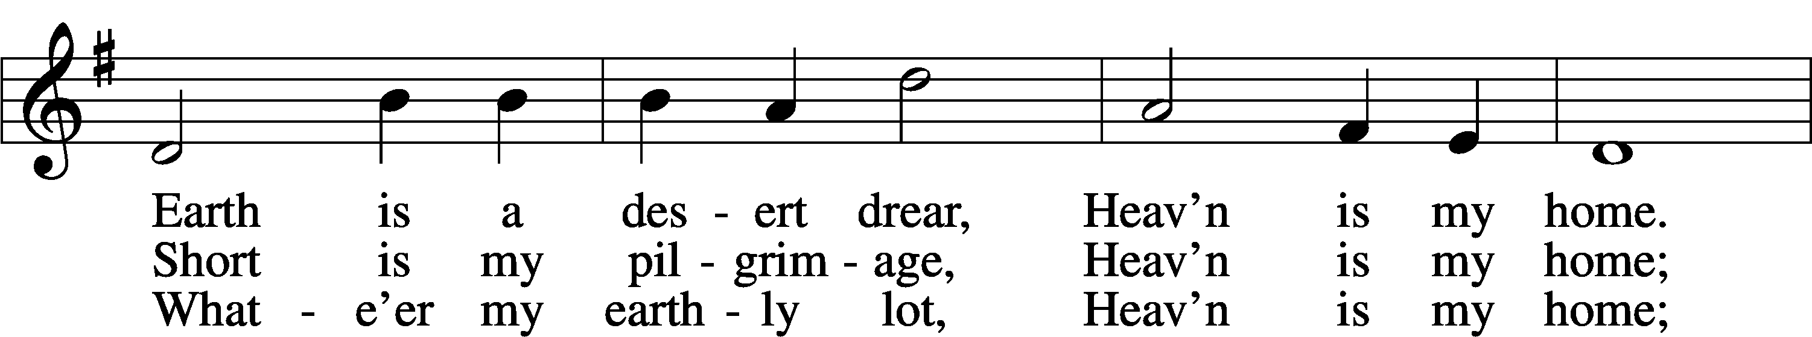
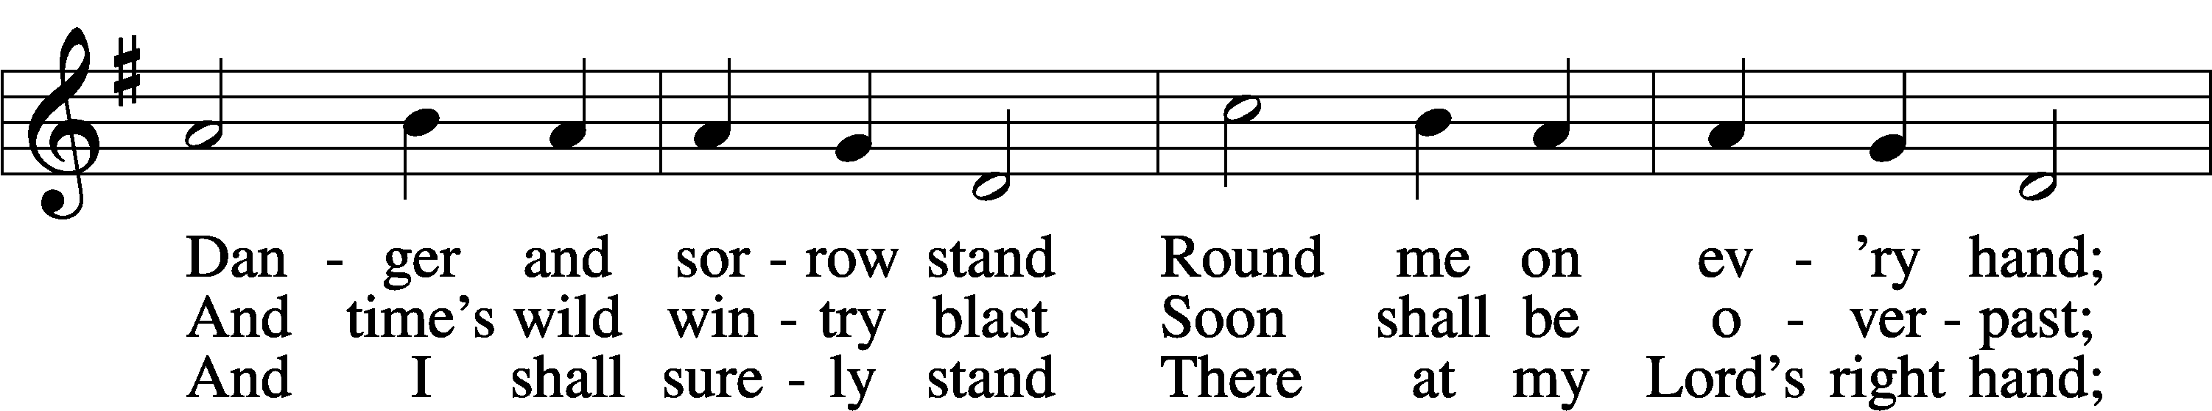
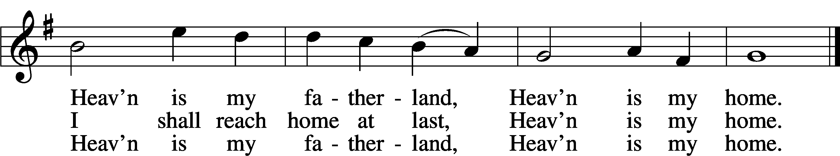

ANNOUNCEMENTS and SENDING WORDS
P We go to live for Jesus!
C We go to share His love!

Acknowledgments
Unless otherwise indicated, Scripture quotations are from the ESV® Bible (The Holy Bible, English Standard Version®), copyright 2001 by Crossway, a publishing ministry of Good News Publishers. Used by permission. All rights reserved. Created by Lutheran Service Builder. Music reproduced in this service is used with permission through: CCLI License No.1776588 and CPH – LSB Service Builder.

SERVING in GODS HOUSE TODAY
Pastor: Rev. Ken Bernthal
Elder: Ken Mertz
Ushers: Tom & Teri Stiles
Greeters: Tom & Terri Raithel
Coffee: LWML Carla Elenz, Kathy Erat
Counters: Wendell Smith, Karl Scheiterlein
Altar Care: Nancy Ely
Piano/Organ: The Beaches
Children’s Talk: Nancy Ely
Sunday School: Sharon Techel, Jean Beach, Nancy Ely
Sunday Morning Bible Study: Dr. Tom Beach
PRAYERS
Please contact the office with updates to the prayer list. People will remain on the prayer list for 4 weeks before being removed. If they need to remain on the list, please keep Elaine informed and of any updates. This will help us to have a more accurate list. Thanks for your cooperation.
ration.
Those who continue to grieve the passing of loved ones:
Those with upcoming surgery and medical procedures:
Those recovering from surgery and medical procedures: Tanner Beyers. Roxy Mohr, Roger Raschke, Greg Techel, Joann Whitney, and Bill Stiles
Those with health concerns: Tiffany Amsdill, Wally Beasinger, Ruth Bennett (Sharron Kato’s Sister), Jackie Bliss, Hope Buchinger, Betsy Cook, Shirley Hilderbrand, Paul Kietzman, Janice Knoellinger, Jennifer Martin, Eleanor Raether, Beth Smith, Judi Stutzman, Joann Whitney.
Those diagnosed with cancer: Sue Cavanagh, Leah Eicher, Rachel Frisch, Sheryl Marsh diagnosed with cancer ( daughter of Shirley Hildebrand), Janice Knoellinger, Leslie Martin, Brian Morgan, and Hope Osantowski. Leanne a friend of Denise Lang’s, was diagnosed with colon cancer.
Those under Hospice Home Care: Ken Williamson, Jim (Joann Whitney’s brother-in law).
BIRTHDAYS: ANNIVERSARIES:
12/16 Sharon Kwapis 12/12 George & Marliese Bahlman

MESSAGES

MEMBER & GUEST CARDS: If you have not filled out a member/guest card, please take the time to fill one out and place it in the plate behind the back pews in our sanctuary.

WEDNESDAY MORNING BIBLE STUDY, 10:00am in the fellowship hall with Pastor Ken Bernthal. There will be no Wednesday Morning Bible Study on December28th.

GREETING CARDS If you are in need of some greeting cards, we carry an array of them in the cabinet next to the office. The cost of the cards is posted on the cabinet. The money collected from the cards goes to LWML to help support Missions.

CANCER and FRIENDS SUPPORT GROUP: The Cancer & Friends Support Group is not just for people going through treatment, or survivors, we are also here for caregiver, spouse, children, and friends. There are times when we can all use someone to talk to during those difficult times. If there is any subject you would like to discuss with me you call or text or at 989-350-4391. Hope you will join us. We meet on the 4th Tuesday of each month in the fellowship hall.

COOKIE DECORATING & EXCHANGE: We have to cancel the cookie decorating and exchange for this year. Unforeseen problems came up which make it impossible to have it at this time.
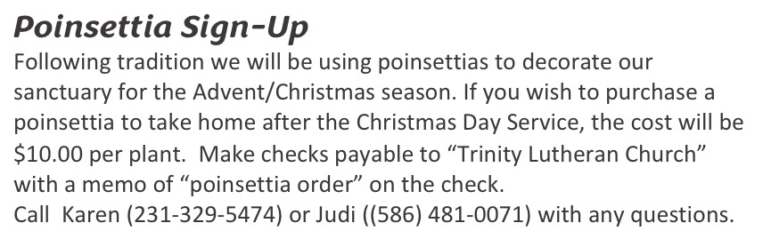
PORTALS OF PRAYER for January - March are in and can be picked up one the shelf in the narthex

SERVING in GODS HOUSE NEXT SUNDAY DECEMBER 18
Pastor: Rev. Pastor Paul Schneider
Elder: Glenn Smith
Ushers: Terri Raithel, Ron Tesolin
Greeters: Appold Family
Altar Care: Judi Stutzman
Counters: Ric Francis, Sandy Smith
Coffee Servers: Kunisch
Virtual Organist: Bob Erat
Children’s Talk: Nancy Ely
Children’s Sunday School: Sharon Techel, Jean Beach and Nancy Ely
Sunday Morning Bible Study: w/ Dr. Tom Beach
THIS WEEK AT TRINITY
December 11 Sunday
9:00 am Worship Service – Rev. Ken Bernthal
10:00 am Fellowship & Coffee Hour
10:30 am Sunday Morning Bible Study W/ Dr. Tom Beach
10:30 am Children’s Sunday School
December 12 Monday
9:00 am NEWSLETTER DEADLINE
7:00 pm Choir
December 13 Tuesday
6:30 pm Church Council Meeting (Fellowship hall)
December 14 Wednesday
10:00 am Wednesday Morning Bible Study W/ Pastor Ken Bernthal
December 15 Thursday
1:00 pm Ladies Guild - Library
7:00 pm Erats Home Bible study Group Erats
December 16 Friday
December 17 Saturday
December 18 Sunday
9:00 am Worship Service - Rev. Paul Schneider
10:00 am Fellowship & Coffee Hour
10:30 am Bible Study with Dr. Tom Beach
10:30 am Children’s Sunday School

